**How to View Budget Reports in PeopleSoft Finance**

Log in to PeopleSoft Finance (see link below).

You will use the same UserID (employee ID number) and password you’re currently using for the other PeopleSoft systems.

<https://finance.williams.edu/psp/fs92prd/?cmd=login>

Follow this navigation – Main Menu – WMS Financial Reports.

Below is a screenshot of how to fill out the screen.

Enter this Fiscal Year (2015)

Then enter a Project number (six digits) or department number (seven digits) and click on Search for Reports.

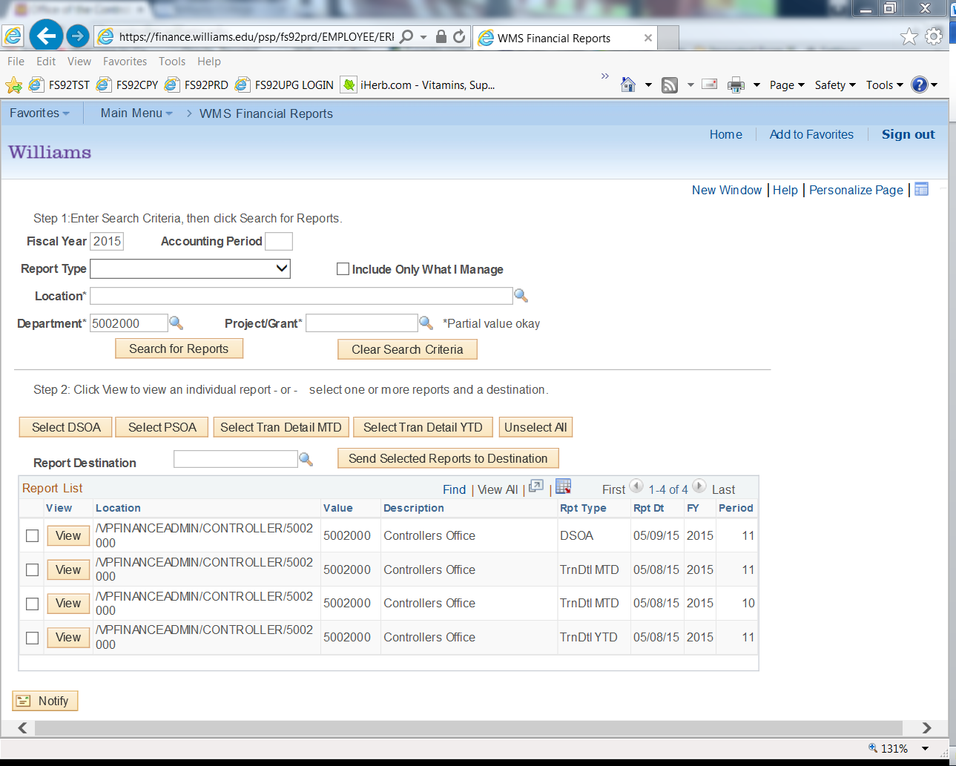

You will see multiple reports (either 4 or 5).

The first report is the summary report which offers a snapshot of all spending for the current Fiscal Year (2015) and also the upcoming fiscal year (2016) – on the far right side of the report.

Open this report (either a DSOA or a PSOA) depending whether you entered a Project # (PSOA) or Department # (DSOA) by checking the box and selecting “View”

On the far right side of the report, you will see the FY 2016 Budget for the project or department you entered. FY 2015 information is also available for your information.

For any technical issues viewing this report, please contact:

Lisa Gazaille - 413-597-4002

Karen Jolin - 413-597-4023

For any budget questions related to this report, please contact:

Kristan Renish – 413-597-4098

Christina Gregory – 413-597-4003